**CYBR472 Lab 07: Data Carving & Analysis**

**greenthom – 300536064**

**Assessment Overview**

In this lab, you will demonstrate your understanding of file carving techniques and your ability to recover deleted files from digital evidence. Using both manual and automated methods, you will extract various file types and analyze their contents. This lab is worth 6% of your total course grade.

**Submission Requirements**

* Heading for the report with lab number, your name, and student ID
* Screenshots as indicated (with personalization requirements)
* Brief descriptions only when specifically requested
* There are 5 questions in total
* Submit as a single PDF document

**Part 1: Manual File Carving with a Hex Editor (30 marks)**

Using HxD Hex Editor, you will manually locate and extract files based on their file signatures.

**1) JPEG Image Carving (10 marks)**

* **Load the provided evidence file in HxD Hex Editor**
* **Locate a JPEG file using its header signature (FF D8 FF E0)**
* **Find the footer signature (FF D9)**
* **Extract and save the file, include your student ID in the file name (e.g. FOR_LAB_007_12345678.jpg)**
* **When viewing the file, make sure filename is visible in the title bar of the viewer**
* **Provide screenshots showing:**
  + **The hex view with the JPEG header signature highlighted (step 4.3)**

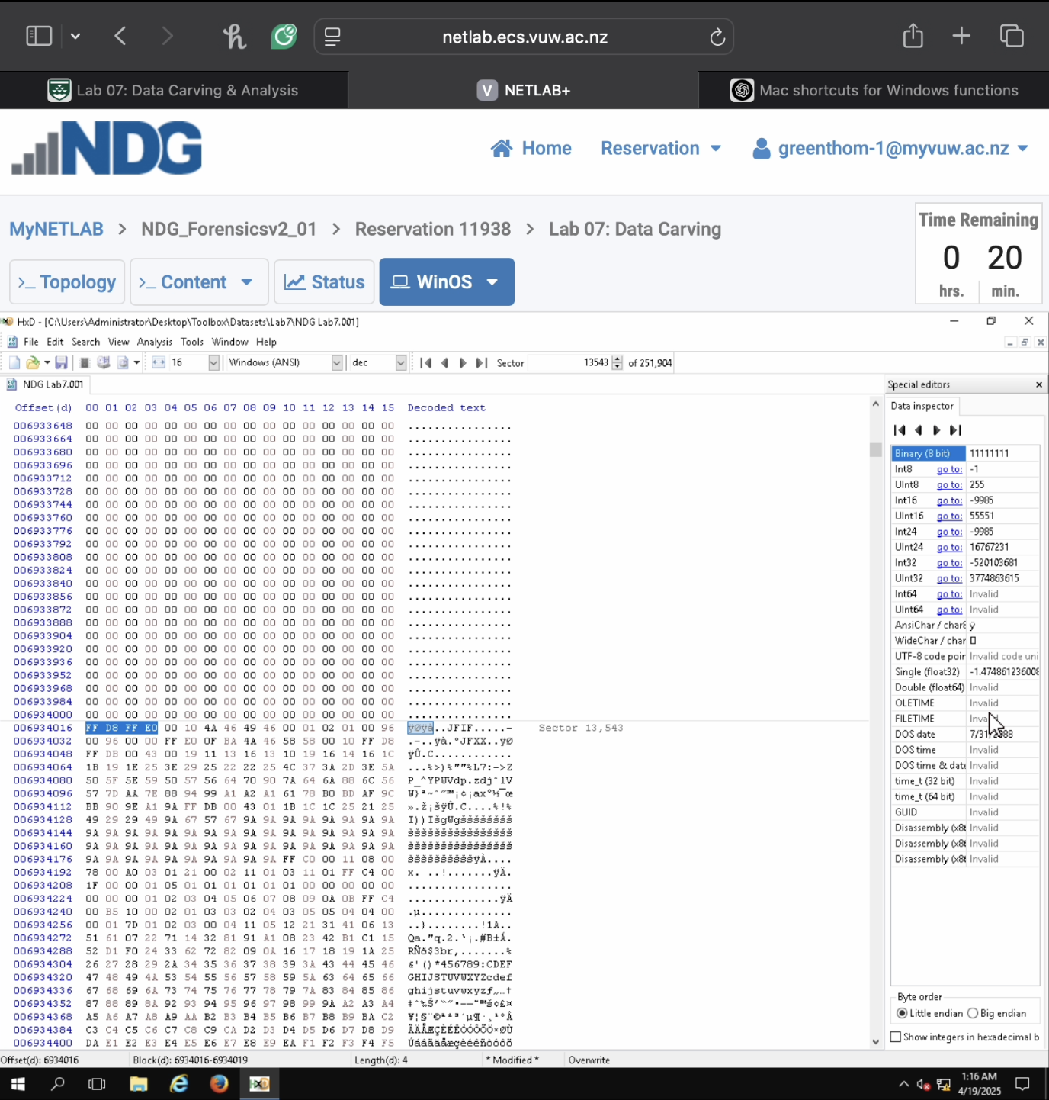

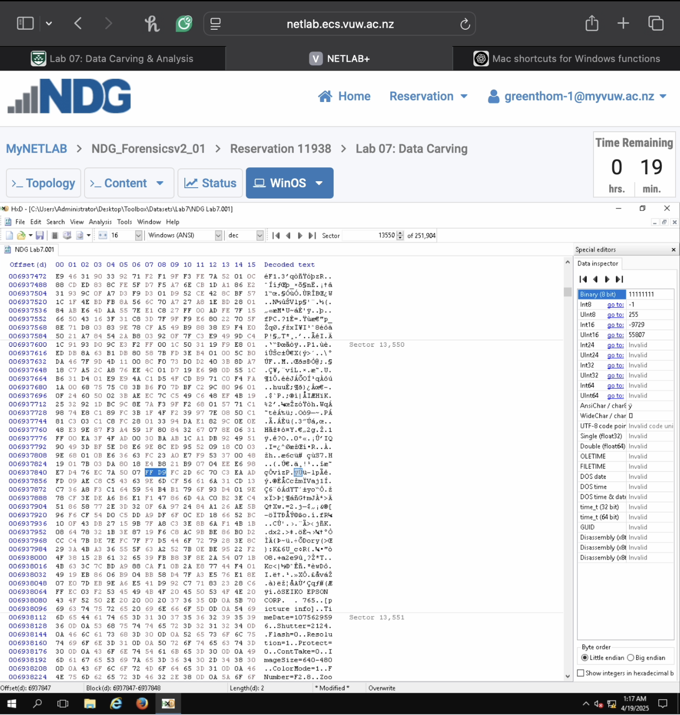

* + **The saved image opened in an image viewer (step 4.12)**

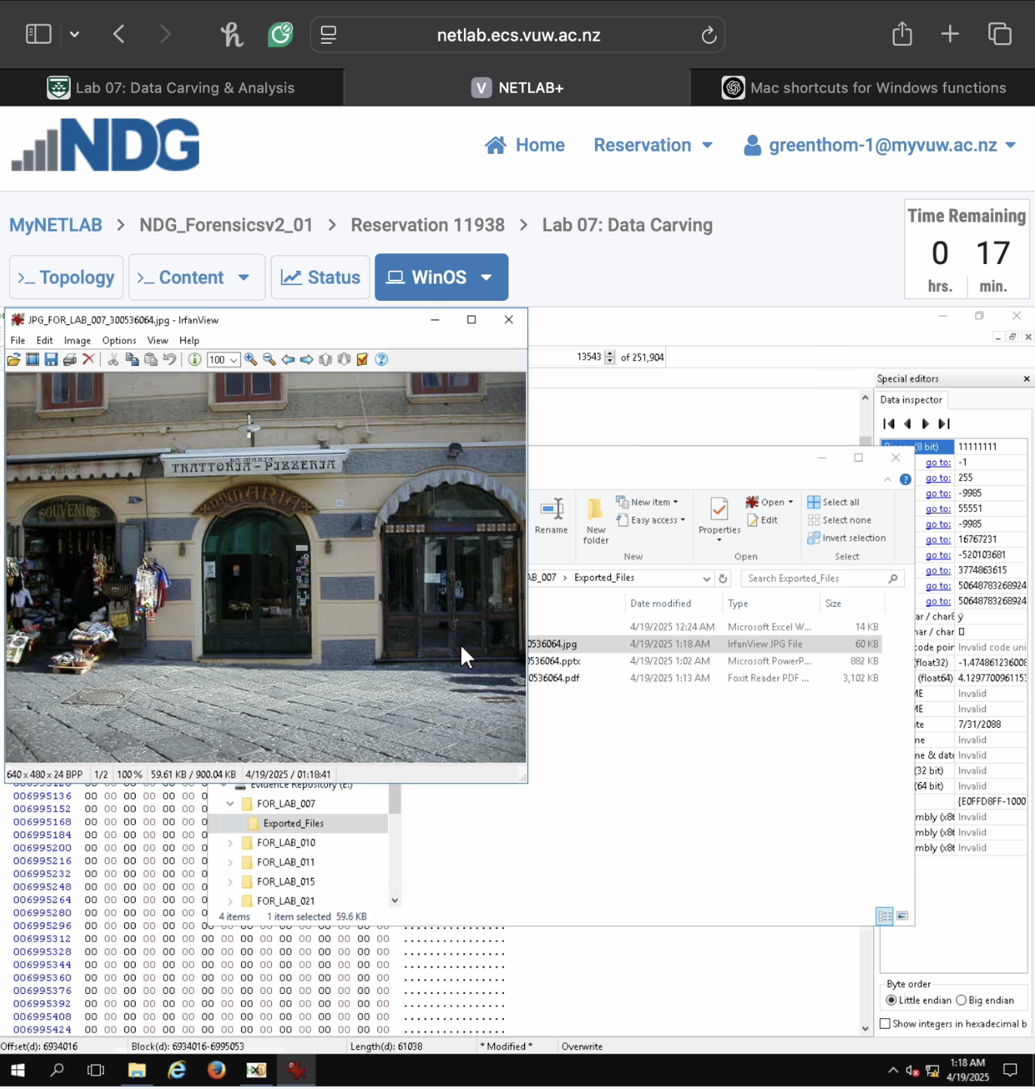

**2) PDF Document Carving (10 marks)**

* **Locate a PDF file using its header signature (25 50 44 46)**
* **Find the EOF marker (%%EOF)**
* **Extract and save the file, include your student ID in the file name (e.g., FOR_LAB_007_12345678.pdf)**
* **When viewing the file, make sure filename is visible in the title bar of the viewer**
* **Provide screenshots showing:**
  + **The hex view with the PDF header signature highlighted (step 3.3)**

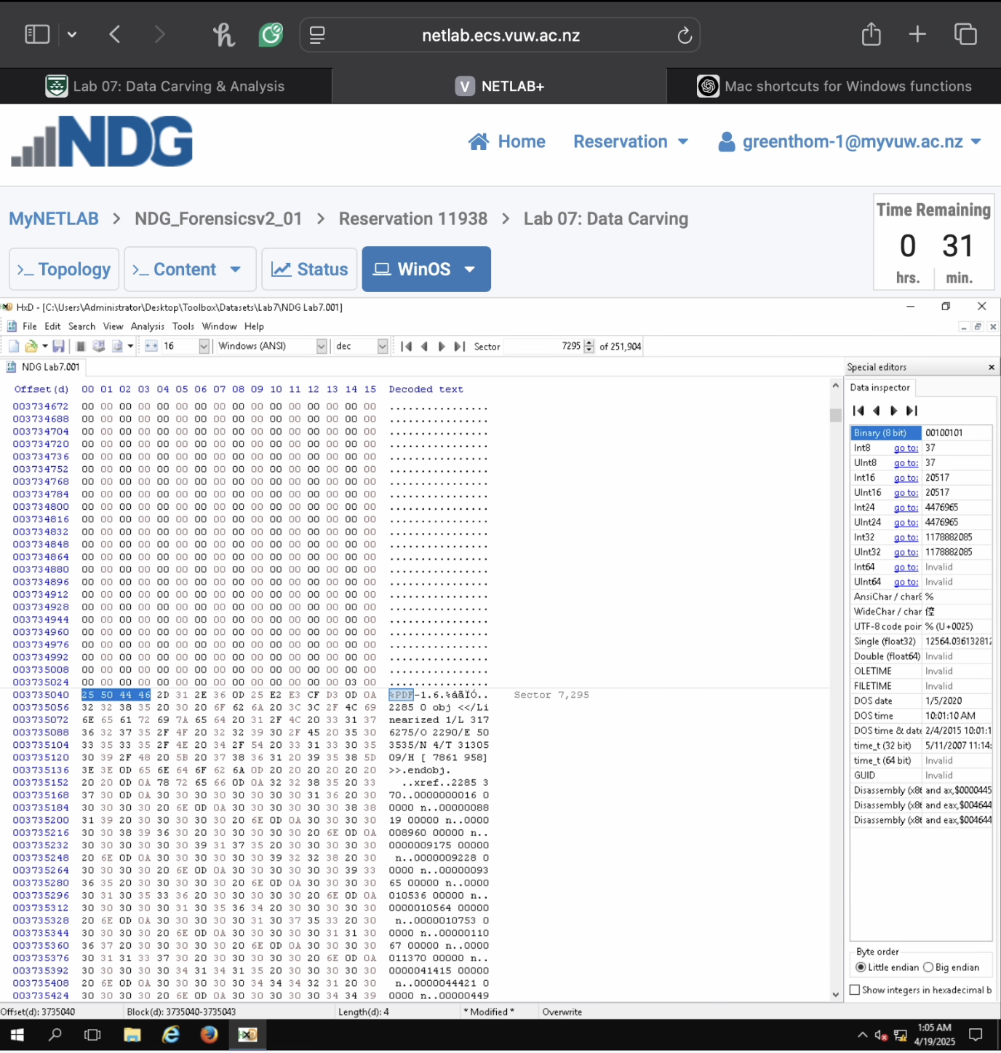

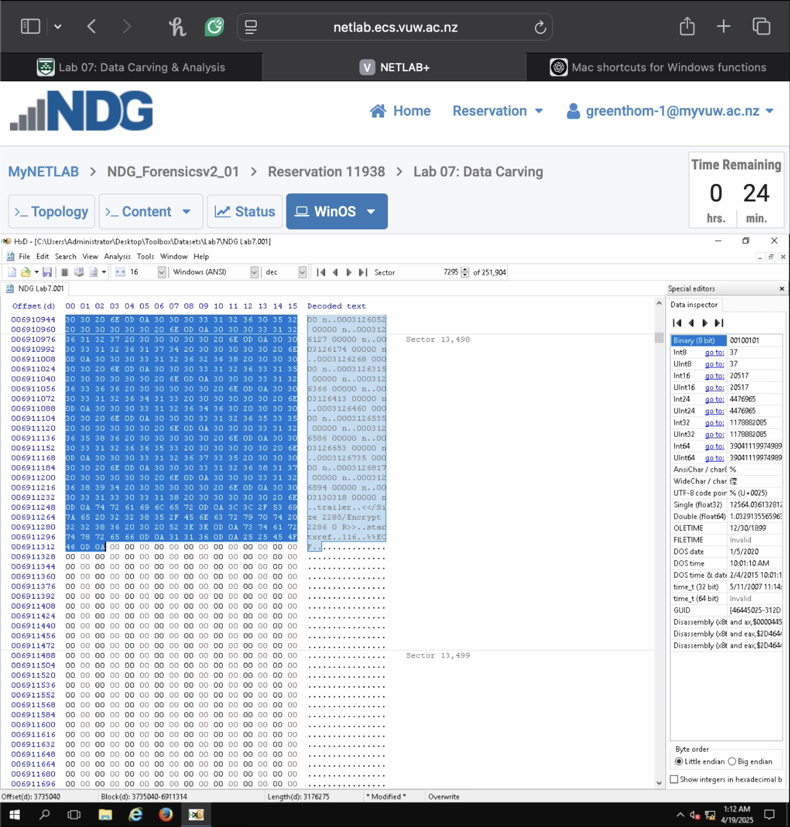

* + **The saved PDF document opened in a PDF viewer (step 3.12)**

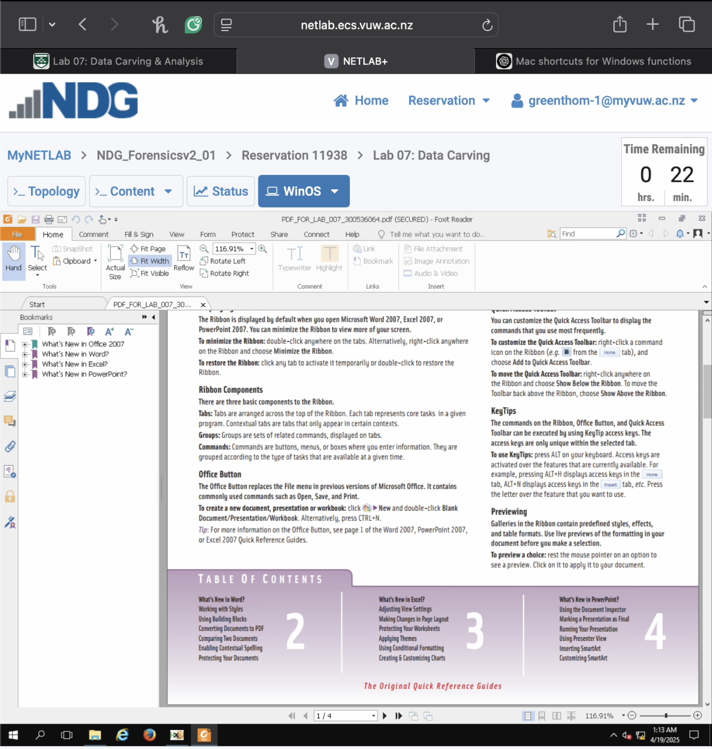

**3) MS Office Document Carving (10 marks)**

* **Locate a Microsoft Office document NOT THE EXAMPLE ONE FROM THE LABE INSTRUCTIONS (DOCX/XLSX/PPTX) using its signature (50 4B 03 04)**
* **Extract and save the file, include your student ID in the file name (e.g., FOR_LAB_007_12345678.docx)**
* **When viewing the file, make sure filename is visible in the title bar of the viewer**
* **Provide screenshots showing:**
  + **The hex view with the document’s header signature highlighted (step 2.3)**

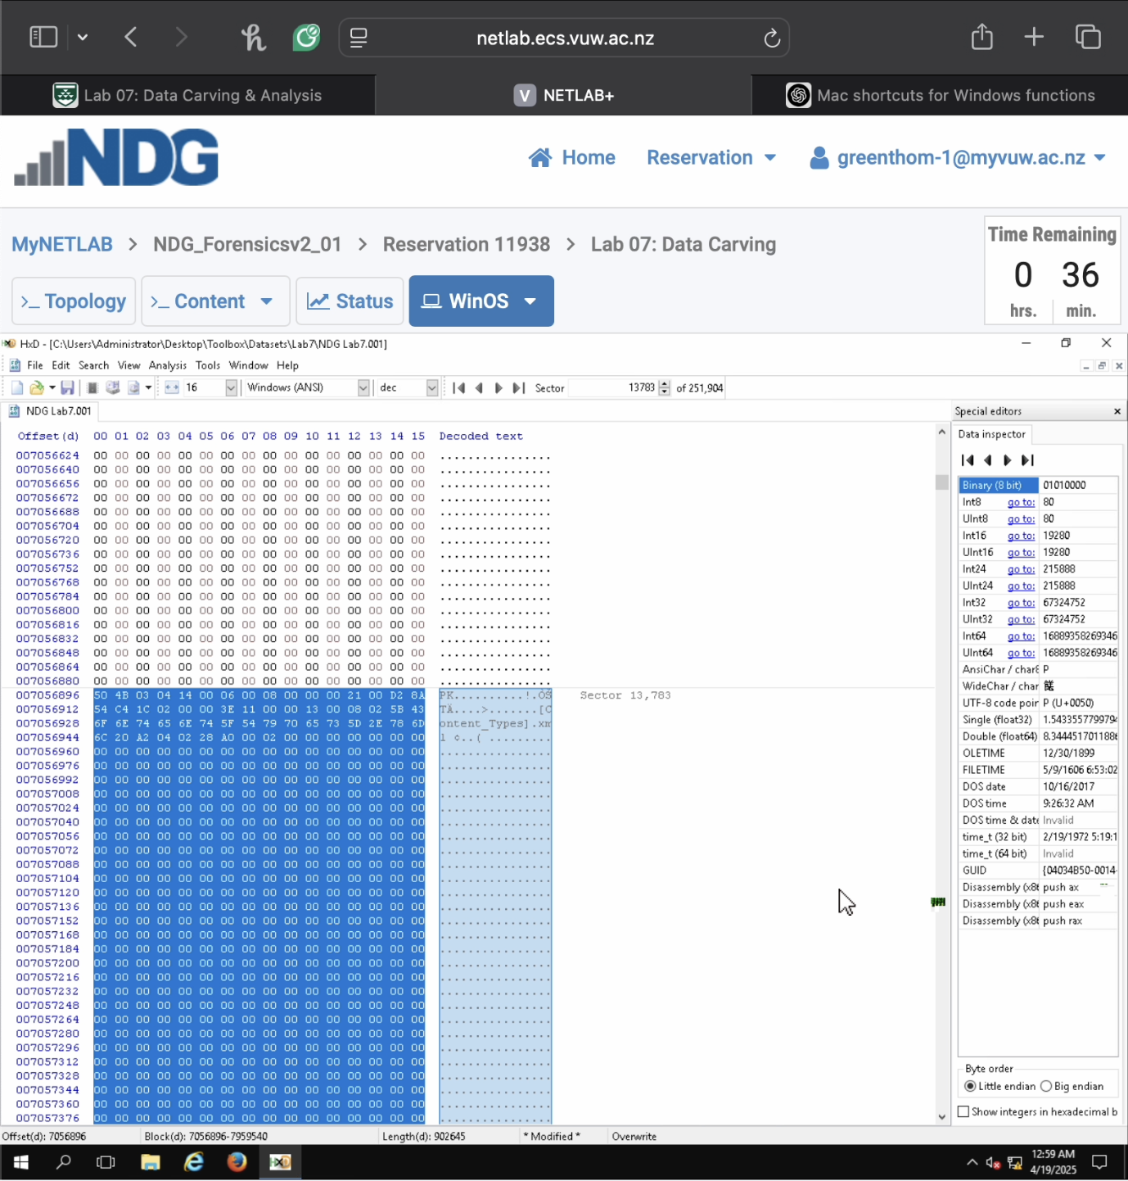



* + **The saved document opened in the appropriate viewer (step 2.12)**

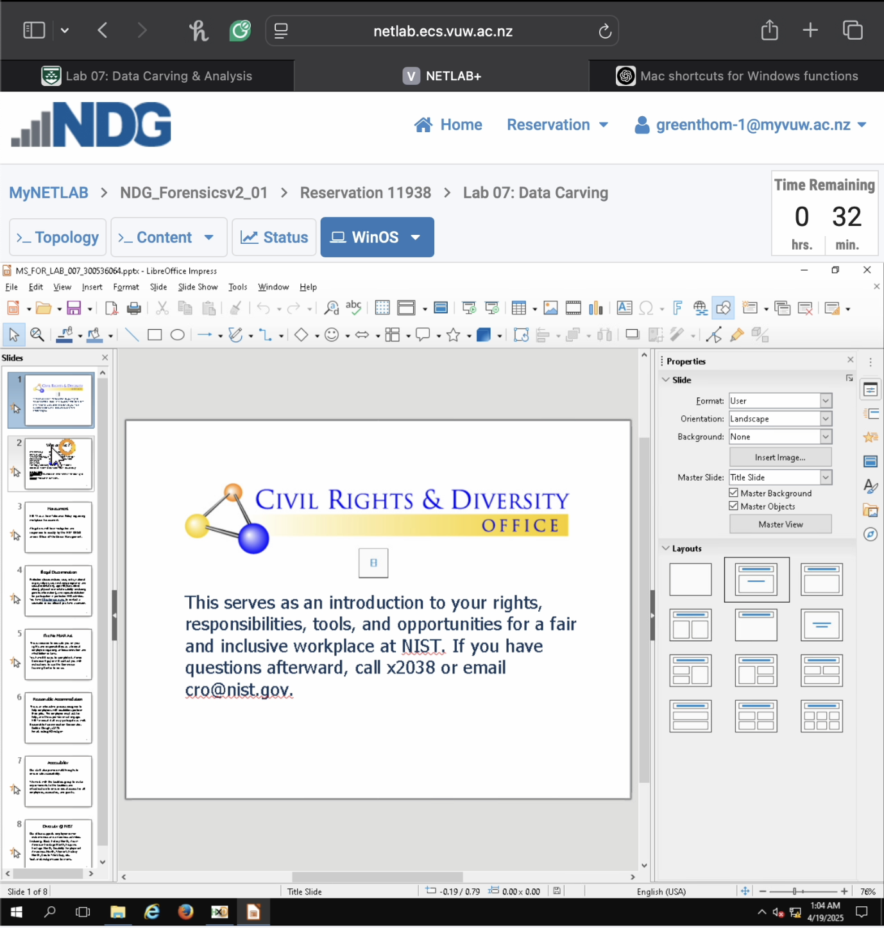

**Part 2: Automated File Carving with Forensic Tools (20 marks)**

Using Autopsy, you will perform automated file carving and analyze the results.

**4) Analyzing Carved Files (10 marks)**

* **Create a new case in Autopsy with your name as examiner**
* **Include your student ID in the case number field (e.g., FOR_LAB_007_12345678)**

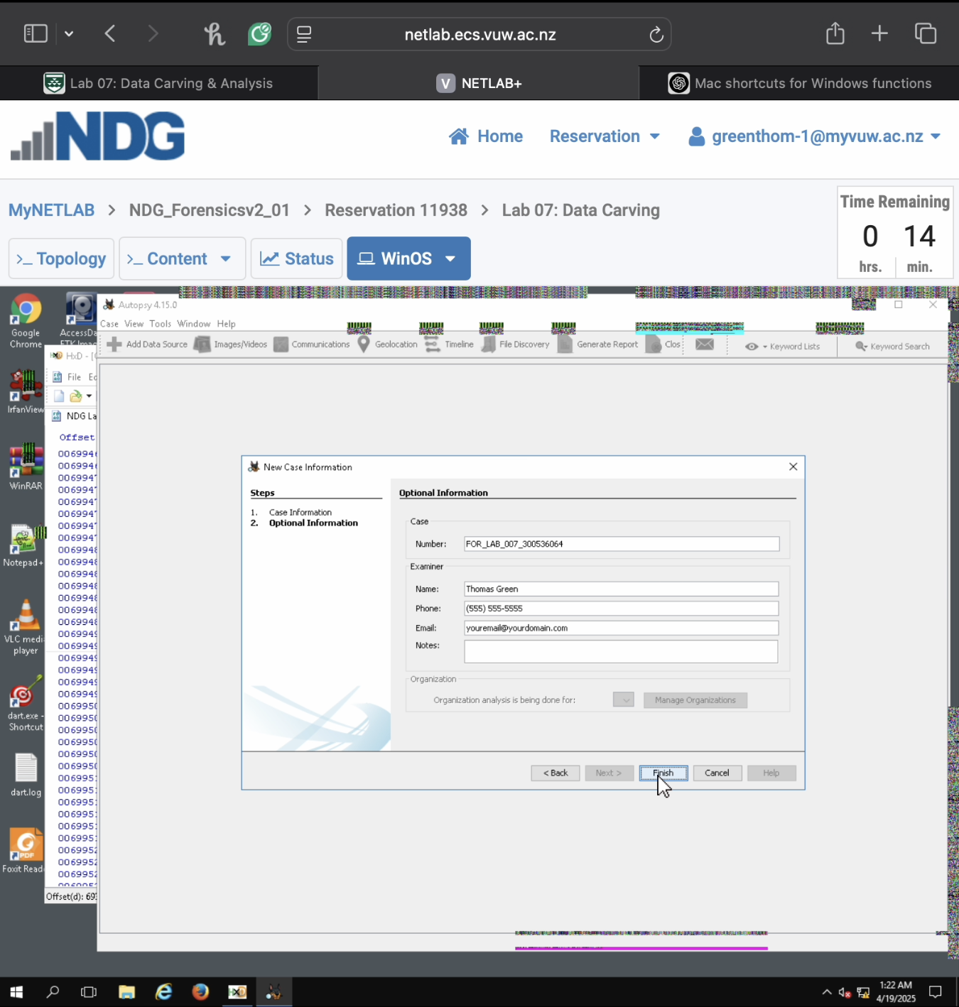

* **Add the provided evidence file as a data source**
* **Configure the PhotoRec Carver Ingest Module**

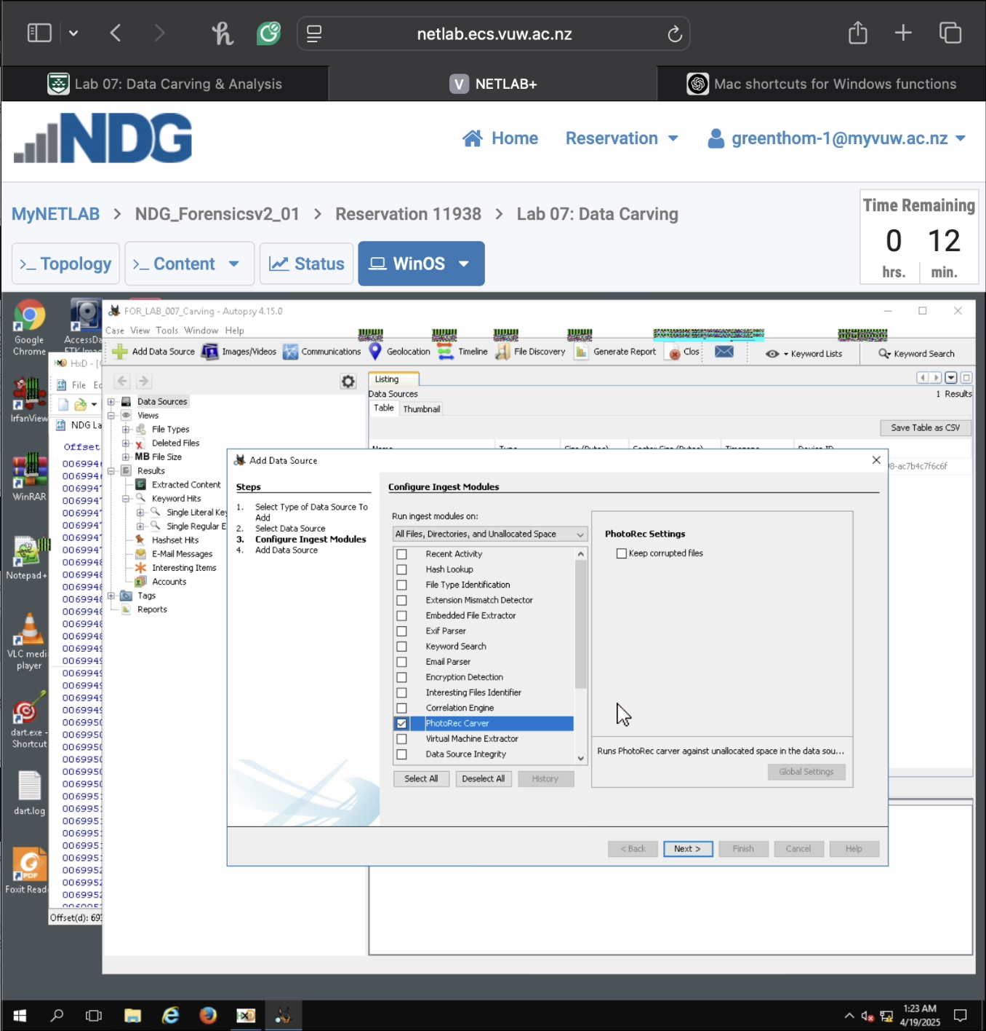

* **Examine the files recovered by Autopsy**
* **Compare the results with your manual carving**
* **Provide screenshots showing:**
  + **The list of carved files in Autopsy (step 15.15)**

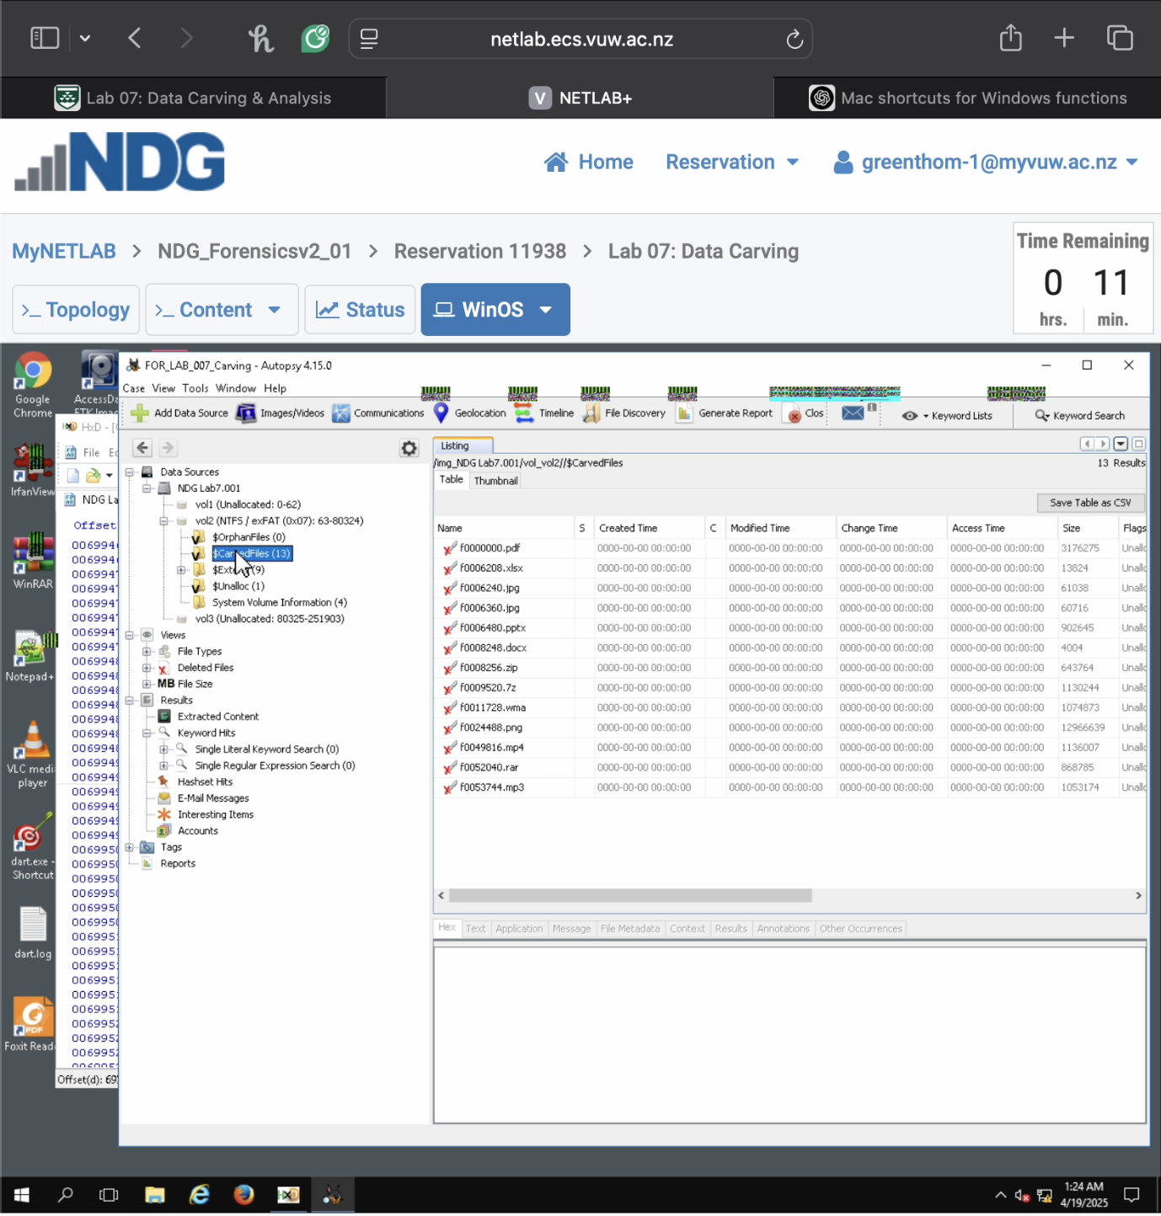

* + **Highlight a file that was successfully carved both manually and automatically (step 15.16)**

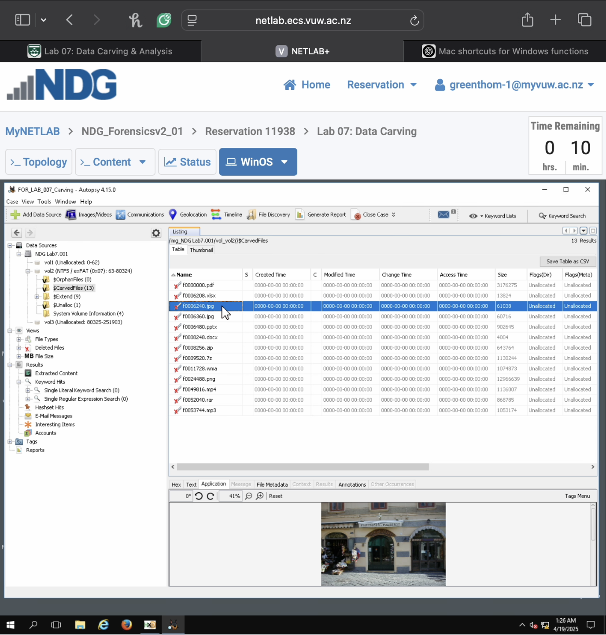

**5) Extracting Embedded Files (10 marks)**

* **Configure the Embedded File Extractor Ingest Module**
* **Run it on the carved files**
* **Provide screenshots showing:**
  + **The Embedded File Extractor configuration (step 15.18)**

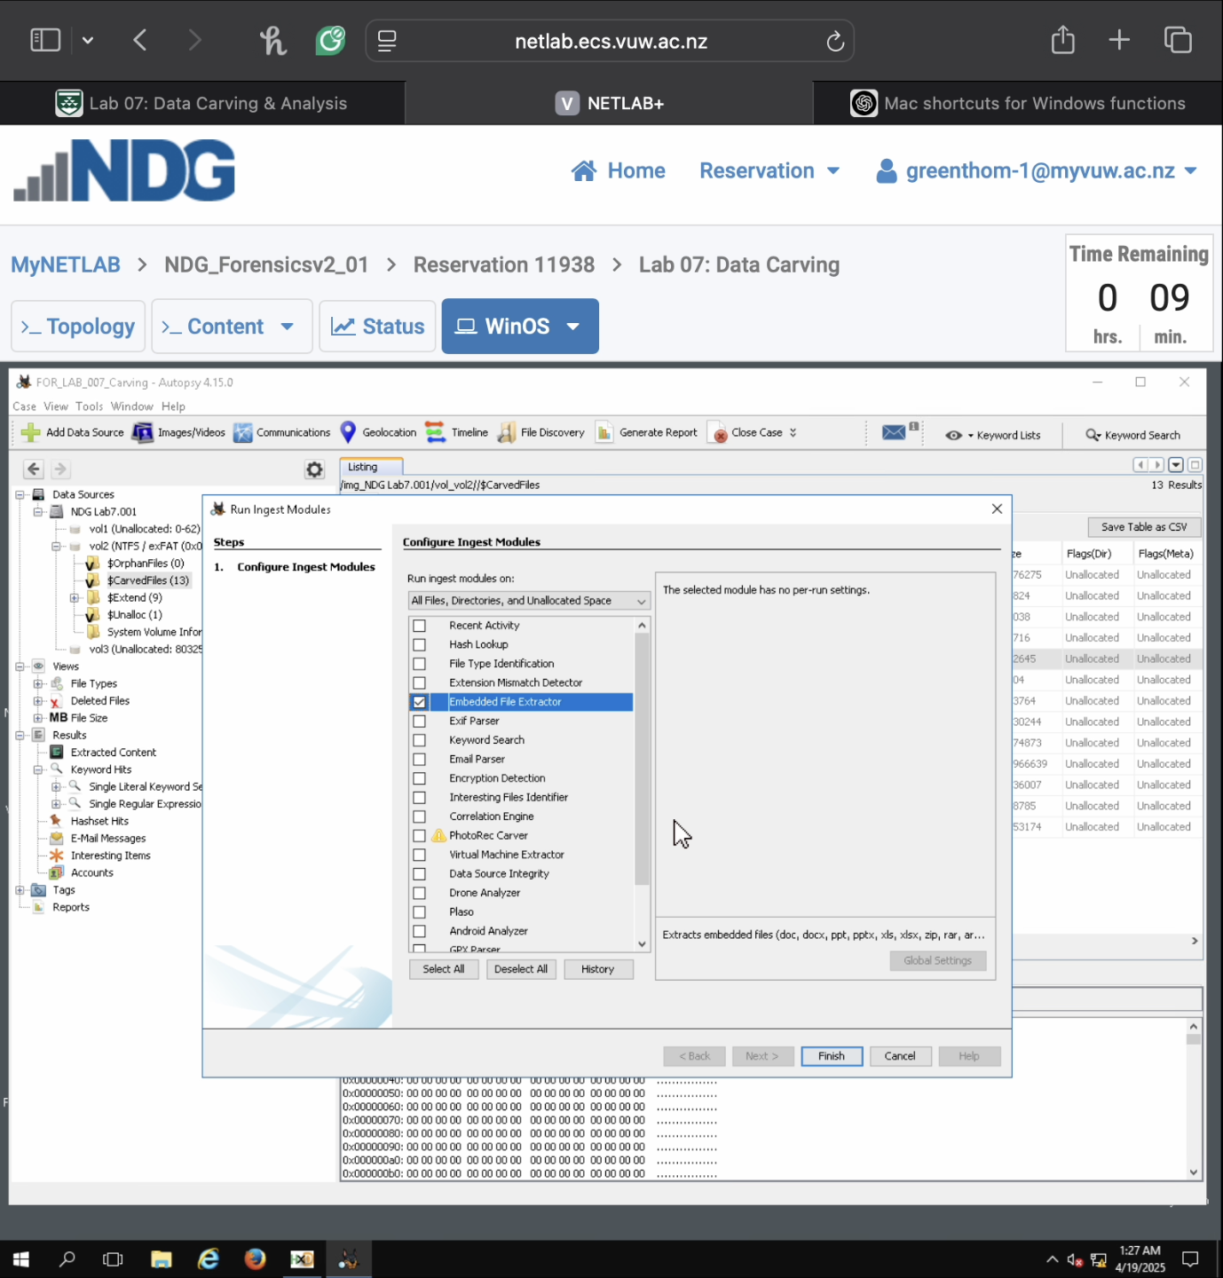

* + **The extracted content from an archive file (step 15.20)**

